Math Center #2
Manipulatives as Thinking Tools - Grade 7
Materials:
- coloured pencils & math notebook (or digital notebook & camera)
- GRADE 7: Pattern Blocks, Cuisinaire Rods, Colour Tiles
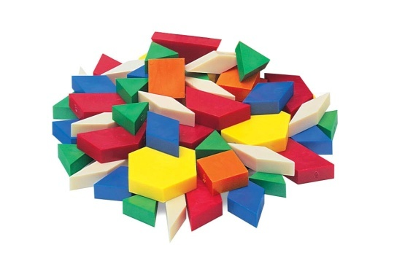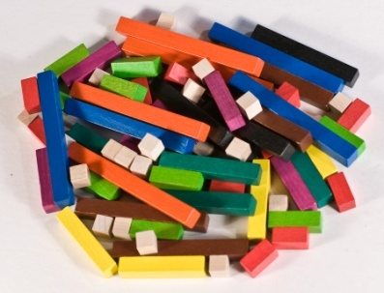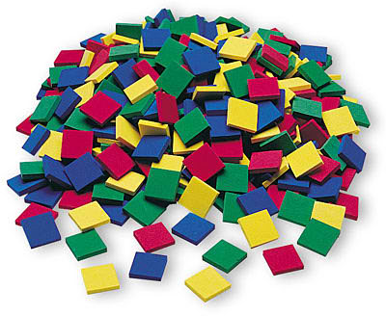
Instructions:
- Write the date and the name of the manipulatives you are using today as the title (e.g. "Pattern Blocks", or "Cuisinaire Rods"). Underline the title.

- Spend some time exploring your manipulatives. What do you notice about them? Sketch or take a photo of each manipulative and label it, describing colour, size, shape, side length, etc.

- Show the fraction 1/2 in different ways, using different manipulatives. Now show 1/4, 2/3 and two other fractions of your choice.

- Fractions can be thought of using a variety of models. One of the models is the "set" model, where fractions are part of a set. Another is the "area" model, where fractions are thought of as one part of a whole area, or region Finally there is the "linear" model, where you can think of part of a number line. Which manipulative do you think best represents each model? Why?

- Tidy up the materials at your centre, thank your peers for their cooperation, and move to the next centre. (Or -- if time is up -- return to your table group.)

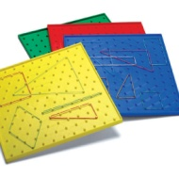
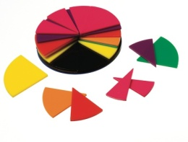
Math Center #2 - GRADE 8
Manipulatives as Thinking Tools
Materials:
- coloured pencils & math notebook (or digital notebook & camera)
- GRADE 8: Fraction Circles and Geoboards
Instructions:
ACTIVITY A - Pizza!
1. Use circular fraction pieces to
create a model of a pizza that
has been cut into pieces.

- Draw the model.
- Write an equation for the model
- Show that the equation is true.

2. Create different "pizzas", using the same procedure.

ACTIVITY B - Cake!
1. Create a geoboard model for
one whole cake that has
been cut into pieces.

- Draw the model.
- Write an equation for the model
- Show that the equation is true.

2. Create different "pizzas", using the same procedure.
HINT: Different models might have...
- a small number of pieces  - a large number of pieces | - The same size for all pieces  - Some pieces the same size, and some pieces of different size

