Math Centre #4
Looking, Reading and Thinking
Materials:
- pencil & math notebook
- visuals: artworks, newspaper articles, photos or other images

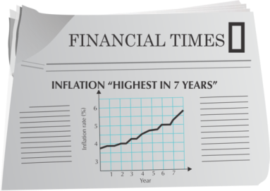
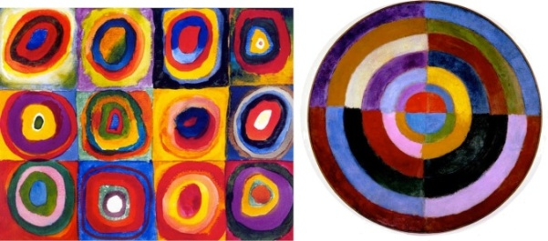

Instructions:
Write today's date and a title. Choose & complete one of the following activities:
ACTIVITY ONE - NEWSPAPER
Option 1
Look through the newspaper, and look for pictures of people. Count the pictures of people. Record the total number. Now count the number of people of colour. What fraction of the pictures include people of colour? This time count the women in the pictures. What percentage of people shown in the pictures are women?
Choose one more difference to examine. Record your findings as a ratio. Write complete sentences for each task above.

Option 2
Look through the newspaper, and find movie ads with people in them. Record the total number of ads you found. Now count the number of people of colour in those ads. What fraction of the pictures include people of colour? This time count the women in the pictures. What percentage of people shown in the pictures are women? Record each of your findings a ratio, a fraction of the whole and a percentage.

ACTIVITY TWO - VISUALS
Choose one of the visuals posted at this center. Look at the image. Respond to the thinking questions below the image.

Some more questions to think about and discuss:

- What does “percent” mean? Which grid is easiest to describe with percent? Why?

- Suppose half of a grid is shaded. Would the grid size matter if you were describing what percent is shaded? Why or why not?

- What size grids would be easiest to describe in terms of percent? Which would be more difficult? Why?

Extension Questions (Optional):

Imagine you were shading 6 squares in each of the following grids:
- A grid with 200 squares  - A grid with 50 squares | - A grid with 500 squares  - A grid with 150 squares
What percent of each grid did you shade in?

Some more questions to think about and discuss:

- What is true about every group of 10 instruments in the picture? How would you write this as a ratio?

- What is a simpler way to describe that ratio? Why is it simpler?

- What is true about 3 out of every 5? How would you write this as a ratio?
- Could you write 24 out of every 60 to describe this picture?

- Why can you multiply both terms of a ratio to get an equivalent one, but not add both terms?

Some more questions to think about and discuss:

- How do you know the number of fills of the measuring scoop is more than 9? How do you know the number of fills is more than 10?

- How full is the measuring scoop for the last bit? How do you know?

- What operation did you use in your number sentence? Why that one?

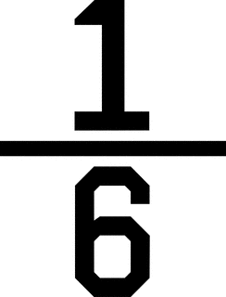
- Why is the quotient 10 and not 10 ?

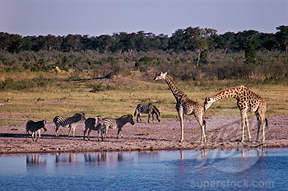
Use ratios, fractions and percents to describe this photo. Write at least three sentences about it.
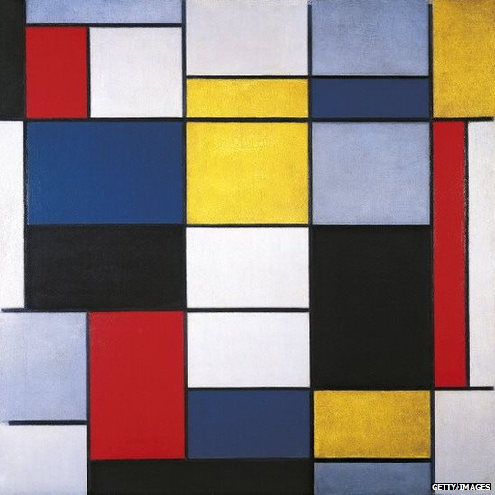
Do you recognize this famous painting?
Describe this painting mathematically, using ratios, fractions and percents.

