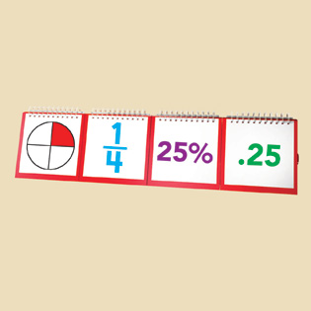

**Centre 6A – Rate & Ratios   
 Problems/Challenges**

1. Build a rectangle with snap cubes. Use green for the width and red for the length. What other rectangles can you build using the same ratio of green to red? Prove it!

Can you use this table to find more equivalent ratios?

|  |  |  |  |  |  |
| --- | --- | --- | --- | --- | --- |
| Component | Rectangle 1 | Rectangle 2 | Rectangle 3 | Rectangle 4 | Rectangle 5 |
| Red Cubes | 6 | 12 | 18 | 24 | 30 |
| Green Cubes | 2 | 4 | 6 | 8 | 10 |

X2

X3

X4

1. Hiba makes her hot chocolate with 2 scoops of chocolate to 5 cups of milk. Nick makes his hot chocolate with 3 scoops of chocolate and 7 cups of milk.

Who makes stronger hot chocolate? Prove it! (consider using snap cubes to represent the chocolate and the milk!)

1. Choose a price for four samosas. Then choose a different number of samosas, and tell how much that new number of samosas would cost.

Tell how you know you are correct.

1. The ratio of stone to sand in Hardfast Concrete is 2 to 3. How much stone is needed if 15 bags of sand are used?



**Centre 6A – Rate & Ratios   
 Problems/Challenges**

1. Which cards match? Why?

|  |  |  |  |
| --- | --- | --- | --- |
| **A** | B | **C** | **D** |
| **E** | **F** | **G** | **H** |
| **J** | **K** | **L** | **M** |

1. Choose fractions for each blank in the sentence below:

Travis was practicing drawing. He filled ______ of a page in ______ of an hour. How many pages would he fill in 1 hour at this rate?

* *How can you look at your fractions and quickly decide whether the rate will be more or less than 1 page per hour?*
* *Are there different fractions you could have used in the blanks that would result in the same rate for 1 hour? How?*
* *Why is it easier to use a unit fraction (with a numerator of 1) in the second blank than a different fraction?*



**Centre 6B – Percent   
 Problems/Challenges**

1. A book costs $18.49. The sales person tells you that the total price, including taxes, is $22.37. How can you tell if the total price is reasonable without using a calculator?
2. The total cost of an item with tax included [115%] is $23.00. Use base ten materials to determine the price before tax.
3. **Option #1**: A number between 20 and 30 is 80% of another number. What could the second number be?

**Option #2**:A number between 20 and 30 is 150% of another number. What could the second number be?

**Consolidation**: *Is the second number greater or less than the first one? How did you decide whether the second number was greater or less than the first one? How far apart are the possible values for the second number?*

1. You know that 60% of the students in a school are participating in a special fundraiser. If between 200 and 400 students are participating, exactly how many total students might be in the school? How do you know? (*Hint: How might this diagram help solve the problem? What if you put the number 350 in the shaded area?*)

|  |  |  |  |  |  |  |  |  |  |
| --- | --- | --- | --- | --- | --- | --- | --- | --- | --- |
|  |  | 300 |  |  |  |  |  |  |  |

1. Choose something you have been wanting to buy that costs more than $50. Imagine you have $30 saved. What discount does the store need to offer before you can afford it?
2. Create a sentence that uses each of the following words and numbers. Other words and numbers can also be used.

*40 percent most 80*

1. Choose a fraction and a percent. Tell which is greater and how you know.



**Centre 6C – Fractions   
 Problems/Challenges**

1. Three people shared a mega nutrition bar.   
Which of the following statements are possible? Explain your reasoning.

a. Greg ate  of the bar, Gursharan ate, and Mo ate.

b. Greg ate  of the bar, Gursharan ate, and Mo ate .

c. Greg ate  of the bar, Gursharan ate, and Mo ate.

d. Greg ate  of the bar, Gursharan ate , and Mo ate.

2. Ms. Legume wants to use  of her garden for lettuce and  for beans.   
What fraction of the garden does she have left for each of her carrots and her peas if they both are to get the same amount of space?

3. Using pattern blocks, show that .

**Option 1:** What other manipulatives could you use to prove this?



**Option 2:** Now use pattern blocks to show

4. Show different ways to find 

5. Show different ways to find 



**Centre 6C – Fractions   
 Problems/Challenges**

6. Find two fractions that have a sum of one.   
 Try to do this as many ways as you can.

7. Mathurshan added two fractions. Their sum was 5/6. Which two fractions   
 might Mathurshan have added. Is there more than one possible answer?

8. Write as many different subtraction questions as you can where the answer is 3/4.

9. Three-quarters of a cake was left over from the Mad Hatter’s Tea Party. Alice   
 ate of the leftover cake. How much of the whole cake did she eat? Make   
 a model to show how you solved the problem.

10. Ms. Teschow baked 72 healthy and delicious muffins for her Grade 8 class.

a) If there are 24 students in the class, how many muffins did each student get?

b) What fraction of the muffins did each student get?

11. Simran had some friends over. Her friends all left their shoes outside the door before entering the house. If 10 shoes were left, how many friends entered the house?

12. Nikola stated that 5/6 is between 4/5 and 6/7. Do you agree? Give reasons for your answer.

13. How many quarters are in a roll of quarters ($10.00)? Explain.



**Centre 6D – More Fractions   
 Problems/Challenges**

14. Shenel and Nathalia are making skipping ropes for *Jump Rope for Heart*. Shenel has 16 metres of rope. She cuts off  of the rope to use as a skipping rope. How long is Shenel’s skipping rope?

15. Art class is $\frac{5}{6}$ of an hour each school day. How many hours of art does a student have in five days. Show your work.

16. Use the fractions 19/10 , 11/3 , 9/4.

a) order the fractions from least to greatest.

b) Write each fraction as a mixed number.

c) Order the mixed numbers from least to greatest.

d) Which method was easier for you: Ordering the improper fractions,   
 or ordering the mixed numbers. Explain.

17. a) If it takes  of an hour to get  of the work done, how long does it take   
 to get all the work done?

b) If it takes  of an hour to do  of the work, how long does it take   
 to do all the work?

c) Describe the parts of a) and b) that are the same and explain what is   
 different.

18. You divide two fractions, and the numerator of the quotient is a 4.   
 What could the fractions be?



**Centre 6D – More Fractions   
 Problems/Challenges**

19. **Option #1:** Describe three different ways to determine – $\frac{5}{3}$ x $\frac{3}{8}$

**Option #2:** Describe three different ways to determine $\frac{4}{5}$ x $\frac{5}{6}$

**Consolidation:** *Will your answer be positive or negative? Will it be more than 1 or less than 1? What do you notice about the numerators and denominators? Which of your strategies do you find simplest? Why?*

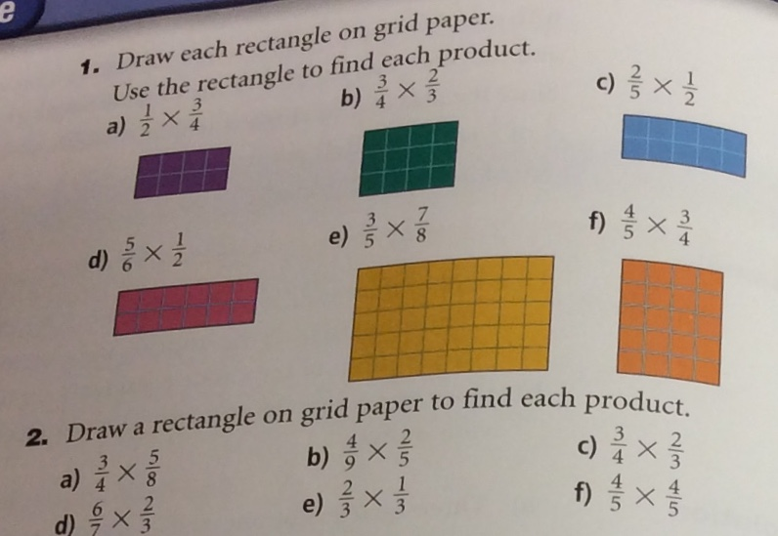

20.

21. The product of two fractions is 2/3. One fraction is 3/5. What is the other fraction? How do you know?

22. Create a real-life problem you might solve by dividing two fractions.