Name: ______________________________ Class: __________ Date: _______________

Ms. Teschow's Hallowe'en Dilemma

Ms. Teschow wants to buy Hallowe'en-themed paper cups and plates to throw a Hallowe'en party for Alex and Simon and a few of their friends. Or maybe a lot of their friends. You see, she can only find cups in packages of 10 and plates in packages of 12, and she really doesn't like to waste things. She is therefore determined to buy the same number of cups as plates, and invite enough people so that each can have one cup and one plate.

What is the smallest number of people she can have at the party under these conditions?

(Extension: What other possible packaging combinations would result in having to invite the same number of guests? Can you list them all? How do you know you've listed them all?)

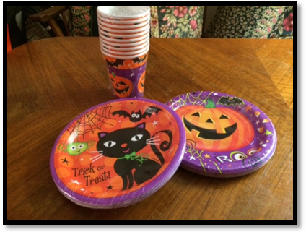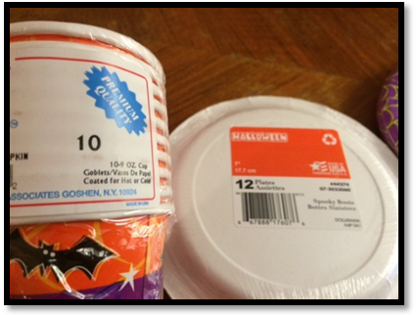

STEP 1 – Understand the problem

Re-read, think about and/or discuss the problem. What are you being asked to find out? What information are you given, and what information do you need?

STEP 2 – Make a Plan

How is this problem similar to other problems you have solved? What strategy or strategies might you use to solve the problem? Represent problem with model, diagram, table or equation.

(over -->)
STEP 3 – Carry Out the Plan

Follow the steps to solve the problem -- show all your work below. Check each step as you work; revise or apply different strategies as necessary.

STEP 4 – Check/Reflect

Reread the question and think about your answer. It is reasonable, and does it make sense? How do you know? Is your solution the most efficient one? Are there other possible solutions to this problem? How do you know? What extensions or variations can you think of?

CATEGORY | LEVEL 1 (D, 50-59%) | LEVEL 2 (C, 60-69%) | LEVEL 3 (B, 70-79%) | LEVEL 4 (A, 80-100%)
Mathematical Thinking | - demonstrates a limited understanding of the problem  - shows little/no evidence of plan  - uses a strategy and attempts to solve the problem but does not arrive at an answer | - demonstrates some understanding of the problem  - shows some evidence of a plan  - carries out the plan to some extent by using a strategy and develops a partial and/or incorrect solution | - demonstrates the expected level of understanding of the problem  - shows evidence of an appropriate plan  - carries out the plan effectively using an appropriate strategy and solving the problem | - demonstrates a thorough understanding of the problem  - shows evidence of a thorough plan  - shows flexibility and insight when carrying out the plan by trying and adapting when necessary one or more strategies to solve problem  - considers extensions or alternate solutions
Communi-cation | • provides a limited or inaccurate explanation /justification that lacks clarity or logical thought  • communicates with limited effectiveness (may include words, diagrams, symbols, and/or numbers) | • provides a partial explanation/justification that shows some clarity and logical thought  • communicates with some effectiveness (may include words, diagrams, symbols, and/or numbers) | - provides a complete, clear, and logical explanation/ justification  - communicates with considerable effectiveness  - reflects on solution with considerable effectiveness (e.g., by assessing the effectiveness of strategies and processes used, by proposing alternative approaches, by judging the reasonableness of results, by verifying solutions) | - provides a thorough, clear, and insightful explanation/ justification  - communicates with a high degree of effectiveness  - reflects on solution with a high degree of insight (e.g., by assessing the effectiveness of strategies and processes used, by proposing alternative approaches, by judging the reasonableness of results, by verifying solutions)

Student Work Assessment Rubric

Dear Family;

Today we worked on the attached math problem together. Students spent part of the period thinking about and discussing the problem with others at their table group, then they worked independently on solving the problem and reflecting.

We invite you to review this problem with your child over the coming days, and use the rubric at the bottom of the second page to help guide your conversation about strengths and gaps. (Feel free to circle or highlight statements that you and your child believe reflect her/his work on this problem.)

Once you have had a chance to review this work, please sign and date below, and feel free to provide any comments or feedback. We value your partnership in the math program! :)

_____________________________________ _____________________________________ _______________
Name Signature date

Strengths, next steps, or other general comments (optional): _____________________________________________________________

_________________________________________________________________________________________________________________________

_________________________________________________________________________________________________________________________

Dear Family;

Today we worked on the attached math problem together. Students spent part of the period thinking about and discussing the problem with others at their table group, then they worked independently on solving the problem and reflecting.

We invite you to review this problem with your child over the coming days, and use the rubric at the bottom of the second page to help guide your conversation about strengths and gaps. (Feel free to circle or highlight statements that you and your child believe reflect her/his work on this problem.)

Once you have had a chance to review this work, please sign and date below, and feel free to provide any comments or feedback. We value your partnership in the math program! :)

_____________________________________ _____________________________________ _______________
Name Signature date

Strengths, next steps, or other general comments (optional): _____________________________________________________________

_________________________________________________________________________________________________________________________

_________________________________________________________________________________________________________________________

