Name: _________________________

“Carding”
Theoretical Probability
vs. Relative Frequency vs. Real Life!

You and your group are police officers patrolling the streets of Toronto. Part of your duties are to engage with the community, and to document information about the people you talk to. Based on the population, over a series of shifts in different neighbourhoods in the city, you “card” 100 people.

Design a spinner to model this experiment, and complete the table below.

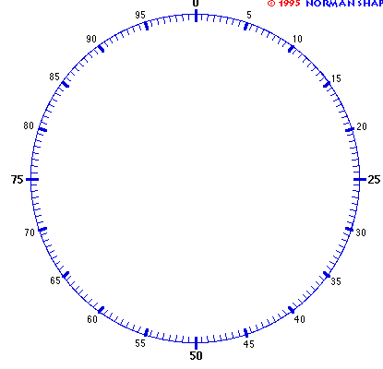

According to a recent national survey in the population of Toronto is as follows:

- Black = 8/100
- South Aisan = 16/100
- White = 53/100
- “Other” = 23/100

A  Ethnicities of people you encounter | B  Theoretical Probability of stopping them | C  How many times people from each ethnic group should be “carded”, THEORETICALLY, if you randomly engage with 100 people | E  Experimental Tally | F  Relative Frequency ethnicity was actually “spun” (RF written as a decimal) | G  Experimental Probability (written as a fraction and percentage)

After your Experiment:

- What was the relative frequency with which you “carded” a black person?

- In a moment, Ms. Teschow and Ms. Grimwood will share actual statistics from Toronto. Do you
think the real life data will be closer to the theoretical probably or the relative frequency from
your experiment? Why?

- After you’ve seen the actual data, what surprises you?

- If “community engagement” were random, a person of colour would have a theoretical probability of _____ of being stopped by the police, while a white person would have a theoretical probability of _____ of being stopped by the police. Specifically, a black person has a theoretical probability of _____ of being stopped by the police.
Statistics show that theoretical probability and relative frequency do not match. In Toronto, a black person has a relative frequency of _____ of being “carded”.

- What are some things you, personally can do to impact change in situations that you perceive
to be unjust?

In real life, not every outcome is equally likely!
Interested in learning more? Check out #whatarethechances or www.genychances.com

