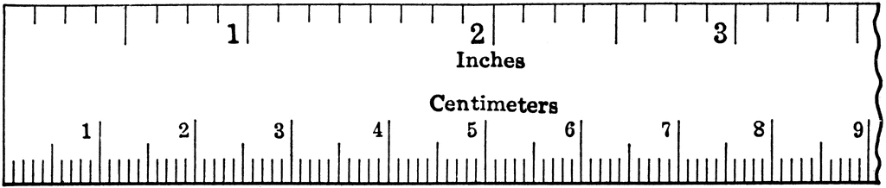
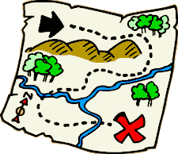
Measurement/Conversion
Map Activity

Name: _____________________

You've decided to run on marked roads for 36 days straight. At the end of day 36 where in Canada might you end your journey? Using the maps provided, the starting points already marked on the maps, and staying on roads figure out what city/town you might end up in.

Success Criteria

- explains distance travelled per day, and justifies answer mathematically
- accurately calculates a total distance travelled
- effectively communicates how far they run each day, using the map, mathematical calculations, and measurement tools
- justifies that final location is a reasonable destination (ending place), using the map and mathematical calculations

FINAL STUDENT ANSWER:
Explain your answer while also showing your work
(use back of paper or extra paper to work out your answer, if needed)

- http://www.mto.gov.on.ca/english/traveller/map/southindexpdf.shtml
- https://www.youtube.com/watch?v=DlT6owR5Ytg

