Grade 7 Measurement Culminating Task
Which bag of Popcorn will you choose?

Learning Goal:
Students will use their knowledge of volume of prisms to make a decision, and justify their decision using mathematical reasoning and effective communication.

Success Criteria:
- Determine the volume and capacity of a variety of 3-D prisms.
- Use measurement concepts to solve problems and make mathematical decisions.
- Use written and verbal communication effectively to justify their mathematical problem solving.
- Use technology/manipulatives to solve problems and justify solutions.

Curriculum Objectives
- sketch different polygonal prisms that share the same volume
- determine, through investigation using a variety of tools (e.g., nets, concrete materials, dynamic geometry software, Polydrons), the surface area of right prisms
- solve problems that involve the surface area and volume of right prisms and that require conversion between metric measures of capacity and volume

Materials Required
- For reference: computers, math dictionaries, textbooks, calculators
- Pre-constructed pop-corn bags – 2-3 versions of each from the task
- Modified lesson – popcorn bags on desk, fewer choices, rectangular/triangular prisms only
- Assignment handouts, observation/conversation assessment tools, snap cubes, rulers, 1000cm cube container, measuring cup, 250mL water

Lesson Outline

Minds On (10 minutes): Water volume vs. capacity demonstration (Have a 1000cm cube container, filled with 1000mL of water. Have a measuring cup also on display. Ask students:
  - What is the volume of this rectangular prism in cm³? The volume is1000cm³.
  - What is the CAPACITY of this measuring cup? It can hold 250mL of liquid.
  - If we know the volume of the rectangular prism, and it’s filled with water, do we know the volume of the water? Yes, it’s also 1000cm³.
  - How do we convert 1000cm³to mL? What’s the conversion? Pour the water into the measuring cup, counting how many mL in total there are. There should be 1000mL. Ask students to complete this math sentence: 1000cm³ = ______mL

Action (30-40 minutes): Have popcorn containers on display, have students ask questions about them. Hand out assignment, have students work on them independently; if they NEED to ask questions, they are to ask a teacher (who will take note of the assistance student needed on tracking form).

Consolidation(10 minutes): Have a few students share their responses, starting with a simple solution, then a more advanced solution. Have students ask questions.

Name: _________________________________________ Date: ________________ Class: ______
Piles of Popcorn
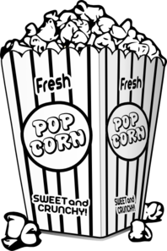
Your goal: Use everything you know about measurement and volume and communication to solve problems related to the popcorn bags at the front of the room!

- Do you think the three prisms will hold the same amount? Do you think one will hold more than the other? Which one? Why?
Assessment hint: review the communication criteria, and check the word wall for useful math vocab!

- Sketch each of the popcorn bags in the space below, and label each prism with its dimensions.

- If all of the bags of Popcorn cost $6.99, which bag will you buy, and why? Use calculations and clear communication to justify your answer.

- Design your own popcorn bag that has a capacity that is more than double the capacity of any of the bags at the front of the room. Make sure to sketch the bag, label all important dimensions, and prove that it’s capacity is actually more than double the others.

- How would you have to change the dimensions of Prism B to make it the same volumeas prism C?

*
Name: _________________________________________ Date: ________________ Class: ______
Piles of Popcorn
Your goal: Use everything you know about measurement & volume& communication to solve problems related to the popcorn bags at the front of the room!

- Do you think the two prisms will hold the same amount? Do you think one will hold more than the other? Which one? Why?
Assessment hint: review the communication criteria, and check the word wall for useful math vocabulary!

- Each popcorn bag is pictured below. Measure the bags (to the nearest cm), fill in the label “blanks”, and then use the labelled dimensions to fill in the blanks!

Bag A Bag B
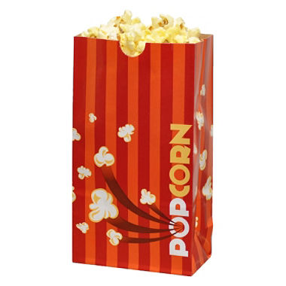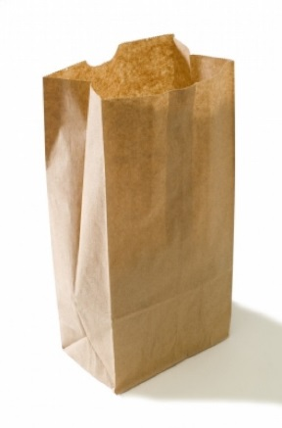

Bag’s Base Width: ______________ cm Bag’s Base Width: ______________ cm
Bag’s Base Length: _____________ cm Bag’s Base Length: _____________ cm
Bag’s Height: __________________ cm Bag’s Height: __________________ cm

- If both bags of Popcorn cost $6.99, which bag will you buy, and why? Use calculations and clear communication to justify your answer.
Assessment hints: what formula(s) will you use to calculate the volume of each popcorn bag? How will you use that information to prove you’ve made a good choice?

- Design your own popcorn bag that has a capacity (that means, a popcorn bag that would hold) just a little bit less than any of the bags at the front of the room. Make sure to sketch the bag, and label all important dimensions.

What is the capacity of your popcorn bag? Prove it!

**
Name: _________________________________________ Date: ________________ Class: ______
Piles of Popcorn
Your goal: Use everything you know about measurement & volume & communication to solve problems related to the popcorn bags at the front of the room!

- Do you think the two prisms will hold the same amount? Do you think one will hold more than the other? Which one? Why?
Assessment hint: review the communication criteria, and check the word wall for useful math vocab!

- Each popcorn bag is pictured below. Use the labelled dimensions to fill in the blanks!

Bag A Bag B

Bag’s Base Width: ______________ cm Bag’s Base Width: ______________ cm
Bag’s Base Length: _____________ cm Bag’s Base Length: _____________ cm
Bag’s Height: __________________ cm Bag’s Height: __________________ cm

- What is the volume of Bag A?
Remember, the formula to find the volume of ANY prism is V = base area x height!

- What is the volume of Bag B?
Remember, the formula to find the volume of ANY prism is V = base area x height!

- If both bags of Popcorn cost the same, which bag will you buy, and why?
Use numbers and words to effectively communicate your answer.

Name: _______________________________ Date: _________________ Class: ____________

Measurement and Manipulatives!
PERIMETER is a measurement idea.
Perimeter is the distance around the outside of an object! It can be measured with a ruler, with a string, or with other things.

- Look at the shapes on the geoboards. Can you count how many SPACES/UNITS there are around the outside of the shape (the perimeter)?

i. P = _______________ ii. P = _______________ iii. P = _______________

- Look at the pattern block shapes. Can you use a ruler to measure the perimeter (how many CENTIMETRES there are around the outside of the shape)?

i. P = _______________ ii. P = _______________ iii.P = _______________

- Look at the drawings of shapes. Can you use the labelled measurements to figure out the perimeter?

i. ii. Iii.

P = _________________ P = _________________ P = _________________

AREA is a measurement idea.
The amount of space that a shape takes up is known as the area.
We count the number of squares that can fit inside a shape to calculate the area. Look at these examples!
It is a TWO DIMENSIONAL (2D) measurement, because we measure the space inside an object with squares, and square have TWO SIDES: a length, and a width.

- Look at the shapes on the geoboard again. Can you count how many SQUARES there are INSIDE the shape (the area)?

i. A = _______________ ii. A = _______________ iii. A = _______________

- Look at the pattern block shapes again. Can you count to determine the area (how many squares there are inside the shape)?

i. A = _______________ ii. A = _______________ iii. A = _______________

- Look at the drawings of shapes again. Your teacher is going to draw the squares into the shapes, based on the labelled measurements. Can you determine the area of the shape in two different ways?

i. ii. Iii.

A = _________________ A = _________________ A = _________________

