Dear Students in Ms. Teschow's Class;
DON'T GIVE UP -- Perseverance Pays Off!
The beauty of mathematics only shows itself to more patient followers.

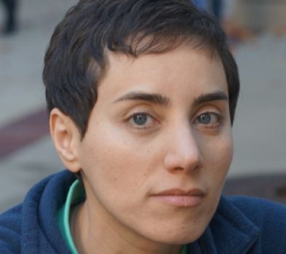
(Maryam Mirzakhani, 2014)

(Michael Fullan, 2013)
It's a conscious choice.
You don't stumble into excellence.

