Hi Students and Families,

Here is some information about how much sleep you might need to be at your best in school and outside of school. A good amount of sleep every night will likely help you to concentrate, feel better, and have more success with friends and with your work.

Please complete the homework assignment at the bottom of the page, and have your parents sign this sheet before returning it to me. Thank you!

Find your age here Sleep you might need

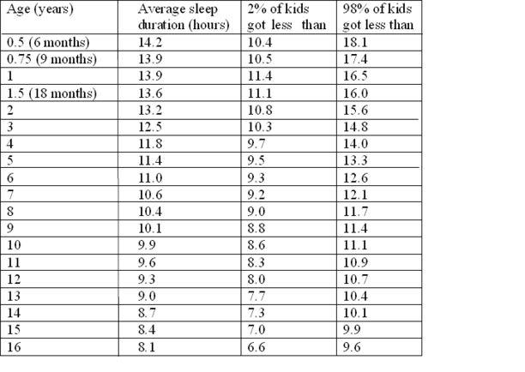

From: The Zurich longitudinal study (Iglowstein et al 2003)

HOMEWORK QUESTION:
If you wake up at 7am, what time would you need to be asleep (not just awake in bed!) in order to get ten hours of sleep? Show your work.

